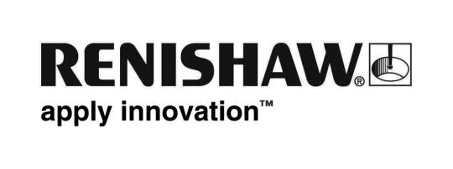
January 2011 – for immediate release Enquiries: Chris Pockett (+44 1453 524133)

Renishaw supports new US HTEC centre with performance testing tool

Haas, one of the world’s leading machine tool manufacturers, has boosted its Haas Technical Education Centre (HTEC) programme in the USA, with the opening of a dedicated HTEC teacher training centre at Vincennes University (VU), Indiana. To support the new facility, Renishaw, a long-term HTEC industrial partner, has donated a QC20-W wireless ballbar, which will be used to help train users of the new centre in the importance of regular machine tool performance testing.
The aim of the new VU HTEC facility (www.vuhtec.org) is to train HTEC teachers from elsewhere in the network, enabling them to affectively deliver the programme within their own learning institutes. The first course at the centre was held in November 2010 and included a combined training course on metrology and ballbar usage, given by Renishaw Inc and Clodfelter Engineering, where the QC20-W ballbar was used to carry out several tests for accuracy and performance on the Haas CNC machining centres installed at the VU HTEC. Attendees included employees from nearby aerospace company Flying-S, as well as VU staff members and students.
Doug Bowman, VU HTEC Director, said, “Ballbar testing is an important process foundation for close tolerance CNC machining and we are pleased to have had the opportunity to host this type of advanced training in our new centre.”
Haas already embraces many Renishaw products in its production and service operations, and offers Haas branded probing solutions as an option on many machines. Telescoping ballbar testing is recognised internationally as the standard test for machine tool positioning performance checking and is used by machine tool builders, end users, service and maintenance companies, and resellers, for pre-production tests, predictive maintenance programs, new machine prove-out, machine grading and comparison, and machine checking after “crashes”. With the development of quality system standards, e.g. ISO 9000 and the implementation of 'Six Sigma' programs, ballbar is increasingly used to define and measure process capability factors.
Already synonymous with telescoping ballbars through its QC10 product, Renishaw's introduction of the wireless QC20-W product in 2009 has encouraged many new customers to discover the benefits of ballbar testing and hundreds of existing users to upgrade to the revised product, which now offers volumetric testing.
Haas is committed to playing a leading role in the development of dedicated facilities within academic and vocational training for machine tool operations and maintenance. A partnership between learning institutions (academic and vocational), Haas Automation and Haas HFOs has been established to ensure that qualified learning institutes receive support to provide the highest quality CNC education, exchange best practices and exploit the power of modern manufacturing equipment for educational purposes. The end result of this is a network of facilities at these learning institutes individually recognised and branded as HTECs (Haas Technical Education Centres). In North America there are currently 988 HTECs http://www.htecnetwork.org with a further 539 in Europe www.HTECNetwork.EU.
More information about Renishaw products can be found at www.renishaw.com.
Ends

