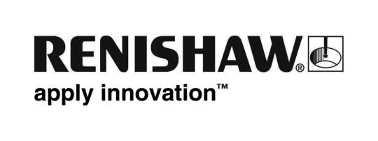
November 2018 Enquiries: Chris Pockett, Head of Communications (+44 1453 524133)

Renishaw and Sandvik power the future of metal Additive Manufacturing

To strengthen the metal additive manufacturing (AM) industry, global engineering company Renishaw has initiated a collaboration with Sandvik Additive Manufacturing to supply the company with high productivity multi-laser RenAM 500Q systems, which will substantially increase Sandvik’s printing capacity.

This is one of the largest installations to date of Renishaw’s latest AM system, the RenAM 500Q. The system features 500 W quad lasers in the most commonly used platform size, enabling a radical increase in productivity, without compromising quality.

Working with ongoing support from Renishaw, the investment will complement Sandvik’s existing printing technologies and strengthen its position in the growing additive manufacturing market. The two companies also intend to collaborate in areas like materials development, AM process technologies and post-processing.

“Renishaw is a leader and innovator in metal AM and metrology, positioning it as the perfect AM partner,” explained Robin Weston, Marketing Manager of Renishaw’s Additive Manufacturing Products Division. “Sandvik is well established throughout the AM value chain, with a leading position in fine metal powder for additive manufacturing and world-leading expertise when it comes to post processing methods like machining, heat treatment and sintering. Our collaboration will strengthen Sandvik’s position during a period of rapid growth in the metal additive manufacturing industries.”

“Sandvik has a leading position within the AM metal powder market and has made sizeable investments in different AM printing process technologies for metal components since 2013. The recent addition of multi-laser RenAM 500Q systems will complement our current printing portfolio in a very good way – and our collaboration with Renishaw will benefit both parties when it comes to capitalizing on the expected rapid growth,” says Kristian Egeberg, President of Sandvik Additive Manufacturing.

As announced previously, Sandvik has initiated extensive investments, amounting to 200 million SEK, in a new plant for manufacturing of titanium and nickel powders for additive manufacturing. The investment will complement Sandvik’s existing Osprey™ powder offering, to include virtually all alloy groups of relevance today – and further strengthen Sandvik’s leading position as a powder supplier to the AM-market.

For more information on Renishaw’s additive manufacturing products and services, visit www.renishaw.com/additive.

Ends 355 words
Notes to editors
UK-based Renishaw is a world leading engineering technologies company, supplying products used for applications as diverse as jet engine and wind turbine manufacture, through to dentistry and brain surgery. It has over 4,500 employees located in the 37 countries where it has wholly owned subsidiary operations.

For the year ended June 2018 Renishaw recorded sales of £611.5 million of which 95% was due to exports. The company’s largest markets are China, the USA, Germany and Japan.

Throughout its history Renishaw has made a significant commitment to research and development, with historically between 13 and 18% of annual sales invested in R&D and engineering. The majority of this R&D and manufacturing of the company’s products is carried out in the UK.

The Company’s success has been recognised with numerous international awards, including eighteen Queen’s Awards recognising achievements in technology, export and innovation.

Further information at www.renishaw.com

